**Sporty Shoes.**

(A**n E-Commerce Website.**)

***(Source Code)***



## Version History:

|  |  |  |
| --- | --- | --- |
| **1.** | **Author Name** | **Ankita Asati.** |
| **2.** | **Purpose** | Source Code. |
| **3.** | **Date** | 28 Feb 2023 |
| **4.** | **Version** | 1.0 |
| **5.** | **Contact** | [*asati.ankita12@gmail.com*](mailto:asati.ankita12@gmail.com) |

Contents.

# User Flow Chart Diagram. 3

1. Folder Structure. 4
2. Project Files. ....**Error! Bookmark not defined.**

# User Flow Chart Diagram.

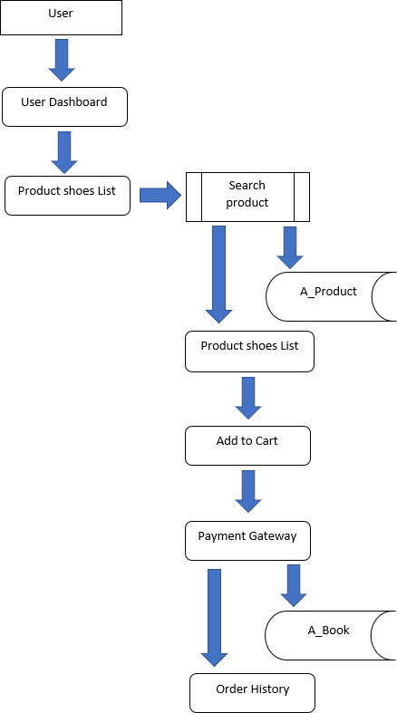

* 1. Folder Structure.

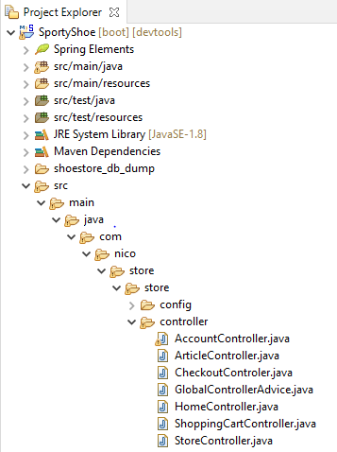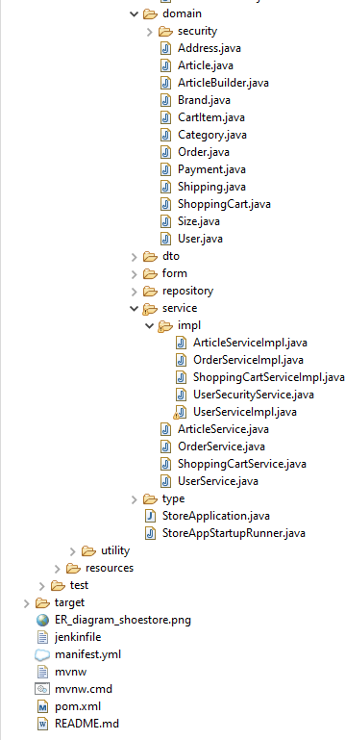

# Project Files.

Rest of the files are present in the given below GitHub link kindly refer this…

Note: For Database ER-Diagram for the reference kindly refer the file ER_diagram_shoestore.png. All database dump file is available inside folder shoestore_db_dump

|  |  |
| --- | --- |
| **Repository Name.** | SportyShoes (1.0). |
| **GitHub Link.** | <https://github.com/ankitaasati/SportyShoes.git> |

1. ***Controller.***

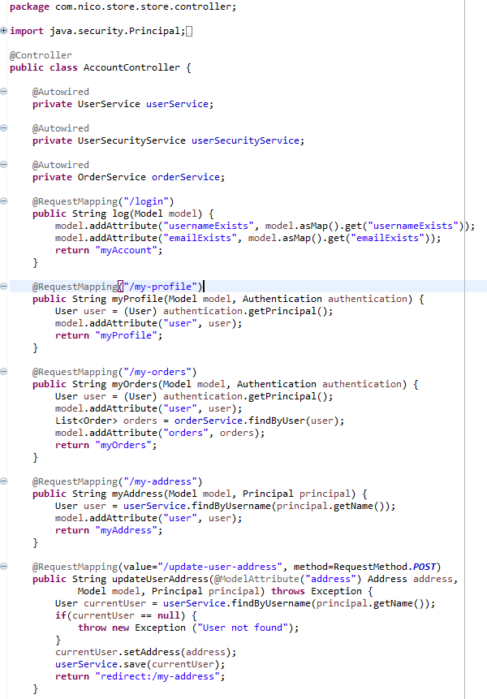

a. AccountController.java

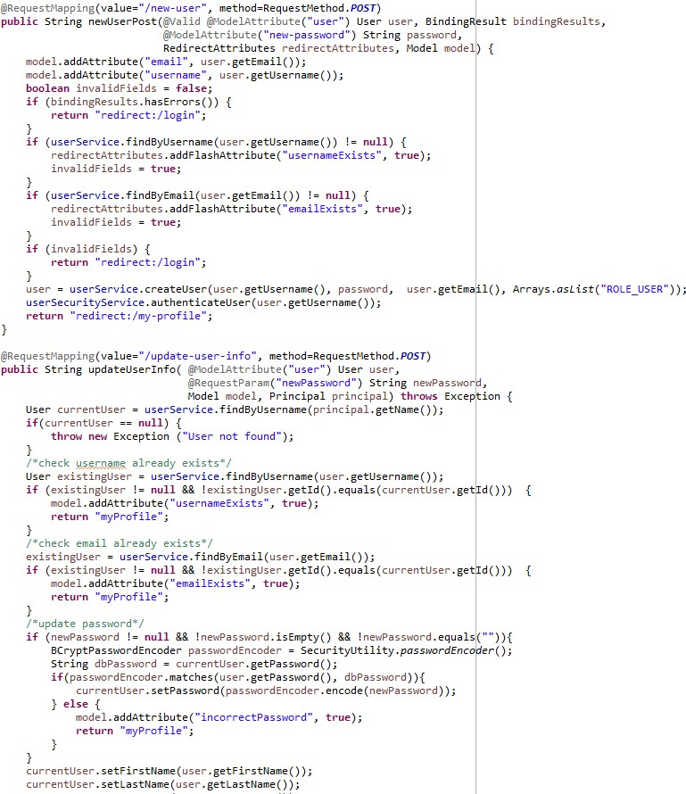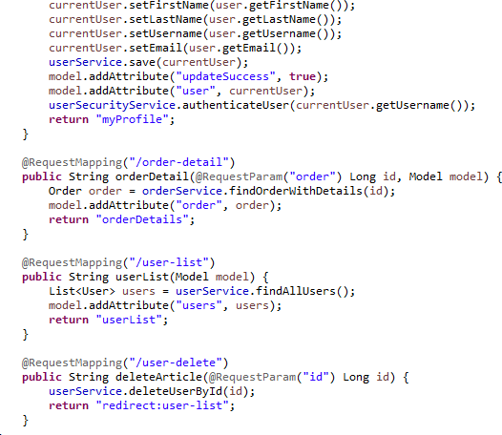

b.ArticleController.java

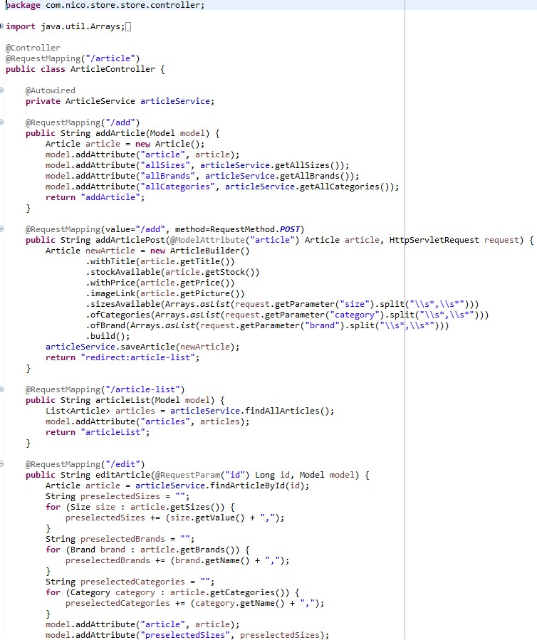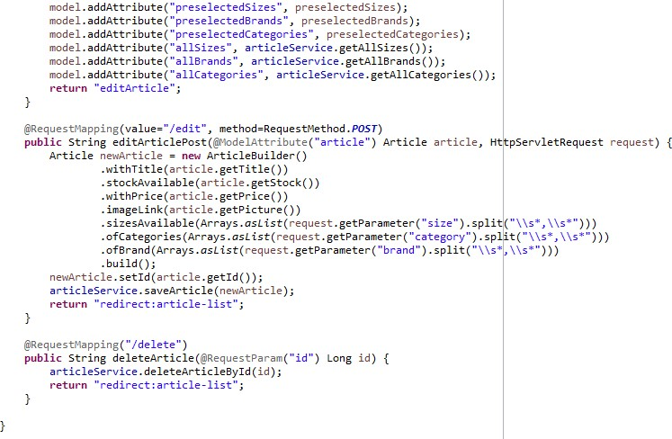

c.Checkout Controler.java.

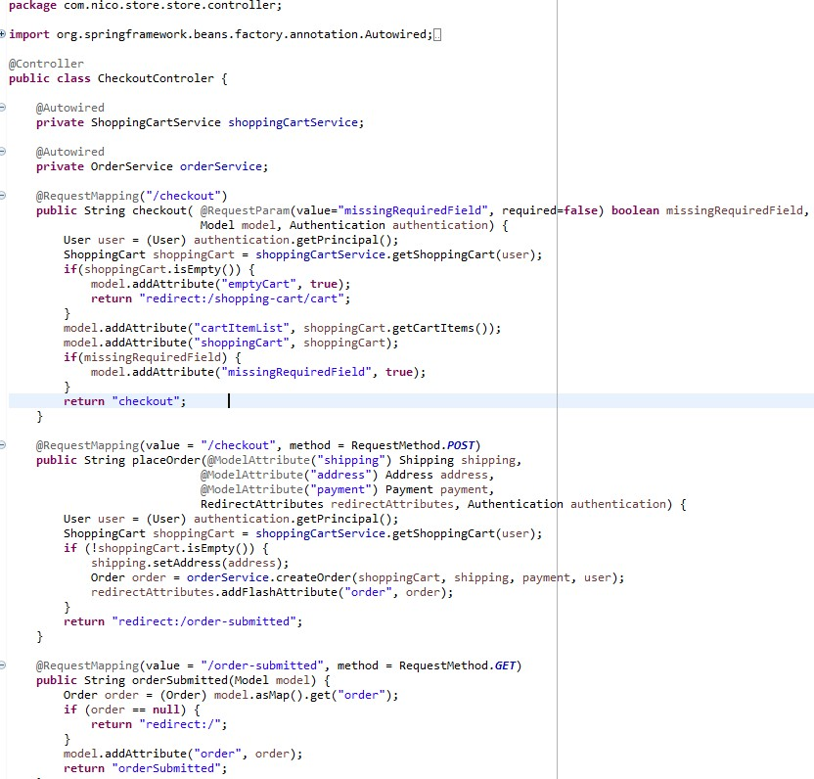

d.GlobalControllerAdvice.java

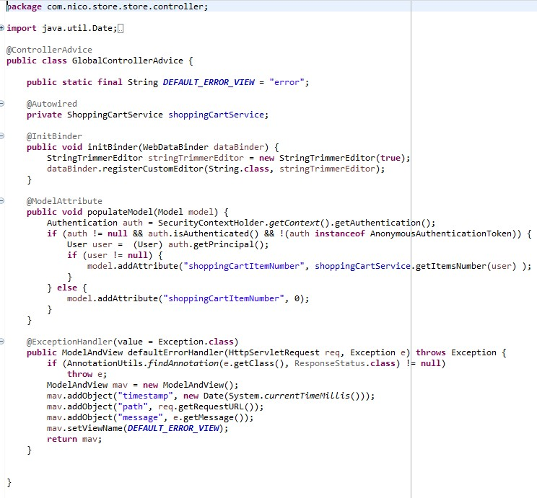

e. HomeController.java

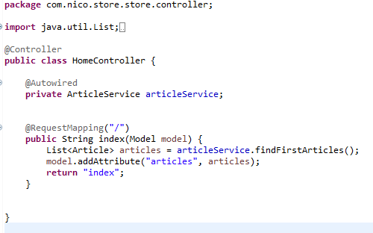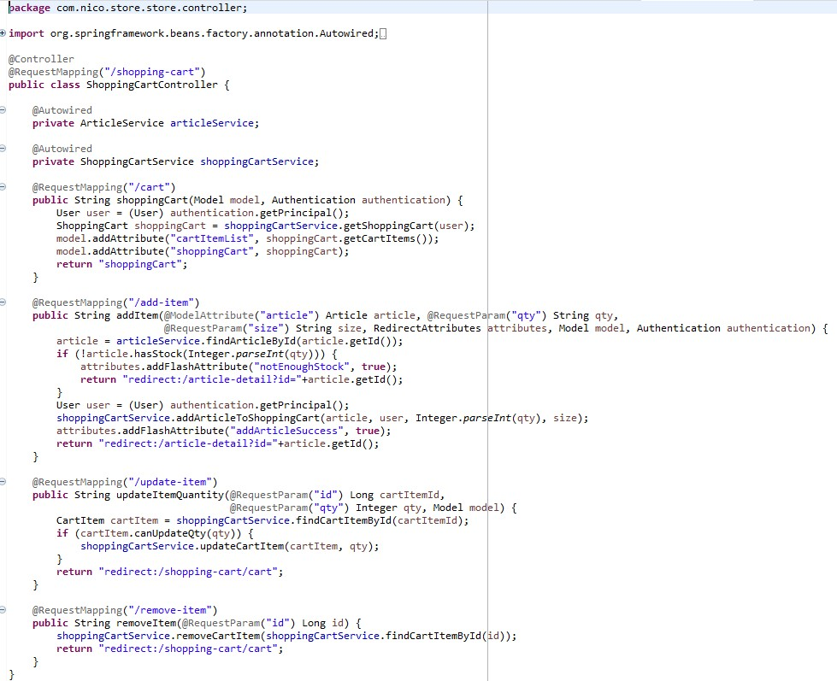

f.ShoppingCartController.java

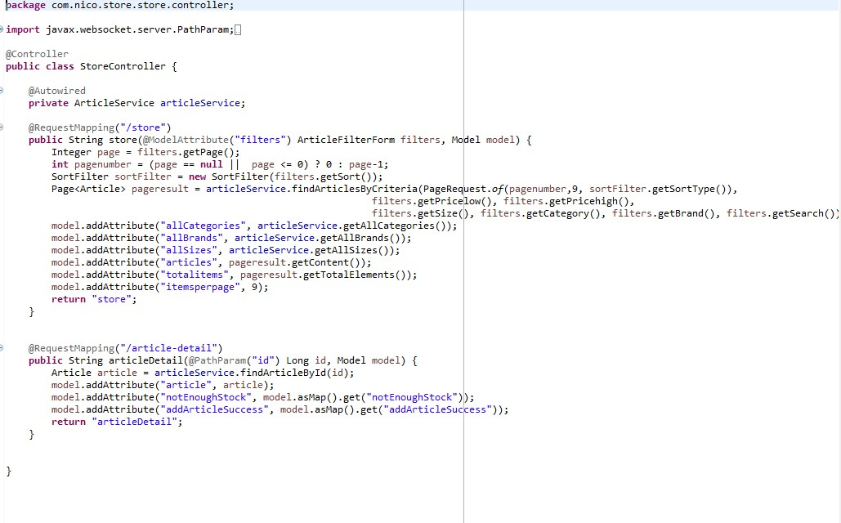

### g.StoreController.java

………………………Thank You………………